Splash Screen Program in Android (Kotlin)

Aim
To create a Splash Screen in an Android application using Kotlin that displays a welcome screen for a few seconds before opening the main activity.

Algorithm
- Create a Splash Activity.
- Design the splash screen layout with logo and title.
- Set the splash screen as the launcher activity in AndroidManifest.xml.
- Use a Handler with a delay to display the splash screen.
- After the delay, navigate to the Main Activity.
- Close the Splash Activity using finish().

MainActivity.kt

class MainActivity : ComponentActivity() {
override fun onCreate(savedInstanceState: Bundle?) {
super.onCreate(savedInstanceState)
setContentView(R.layout.activity_main)
}
}

SplashActivity.kt
Package com.example.myapplicationsc
import android.content.Intent
import android.os.Bundle
import android.os.Handler
import android.os.Looper
import androidx.activity.ComponentActivity
class SplashActivity : ComponentActivity() {
override fun onCreate(savedInstanceState: Bundle?) {
super.onCreate(savedInstanceState)
setContentView(R.layout.splash_screen)
Handler(Looper.getMainLooper()).postDelayed({
val intent = Intent(this, MainActivity::class.java).also {
startActivity(it)
}
finish()
}, 3000)
}
}
Manifest.xml
<activity android:name=".SplashActivity"
android:exported="true">
<intent-filter>
<action android:name="android.intent.action.MAIN" />
<category android:name="android.intent.category.LAUNCHER" />
</intent-filter>
</activity>

Activity_main.xml
<?xml version="1.0" encoding="utf-8"?>
<LinearLayout xmlns:android="http://schemas.android.com/apk/res/android"
android:layout_width="match_parent"
android:layout_height="match_parent"
android:gravity="center"
android:orientation="vertical"
android:background="#FFFFFF">
<ImageView
android:layout_width="300dp"
android:layout_height="300dp"
android:importantForAccessibility="no"
android:src="@mipmap/ic_launcher"/>
<TextView
android:layout_width="wrap_content"
android:layout_height="wrap_content"
android:text="@string/welcome_to_my_app"
android:textSize="24sp"
android:textStyle="bold"
android:layout_marginTop="20dp"/>
</LinearLayout>

OUTPUT
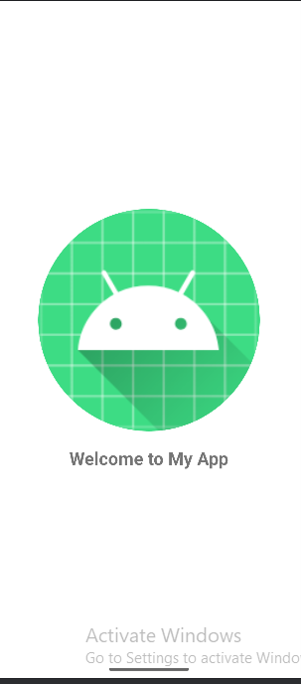
Result
Thus, the Splash Screen was successfully created and displayed for 3 seconds before navigating to the Main Activity.

